|  |  |  |  |  |  |
| --- | --- | --- | --- | --- | --- |
| Date | 11-Dec-22 | | | Tester Name | Mohammad Yusuf |
| Environment | Penfax - Test | | | Login used |  |
| Operating System | Windows | Version: | Update: | | |
| Software Used | Edge | Version: | Update: | | |
| Not Applicable | Version: | Update: | | |
| Release version |  | | | | |
| Title | E7 Fund Transfers | | | | |
| Test Type | Regression | | | | |
| Test Scenario | E7.11 Change Deposit Allocation from 1 account to 3 accounts – PENWEB Negative test to change Deposit Allocations  There should be no letter | | | | |
|  |  | | | | |
| Expected Results | 1. Interfund Transfer should be processed and displayed under member’s account in Penfax and in Member PLANet. 2. PEPP Interfund Transfer Letter should be available. 3. Transcation should be listed on the Daily Valuation Report. | | | | |
| Pass/Fail | Pass | | | JIRA# | N/A |

Describe your steps with screenshots:

1. Search active PEPP member having current deposit allocation in 1 fund by SQL query.
2. Search for the stakeholder. Click on Stakeholder ID.

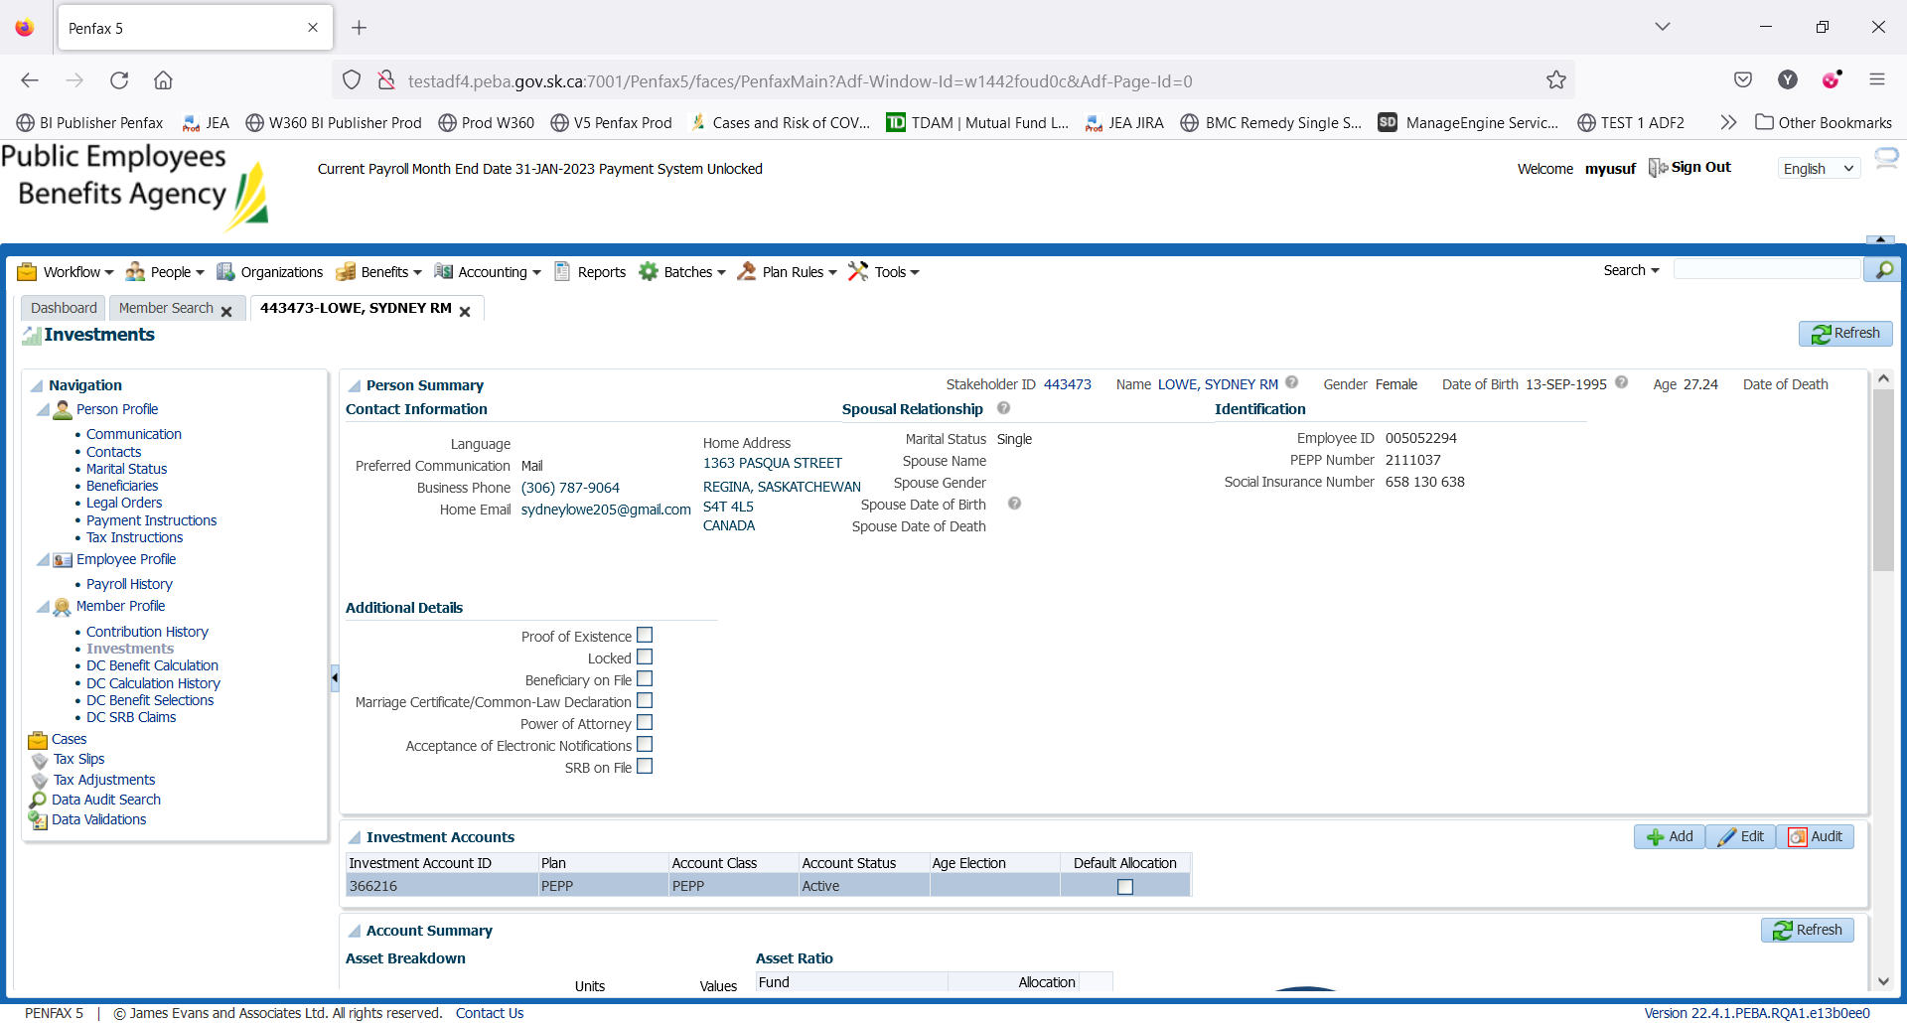

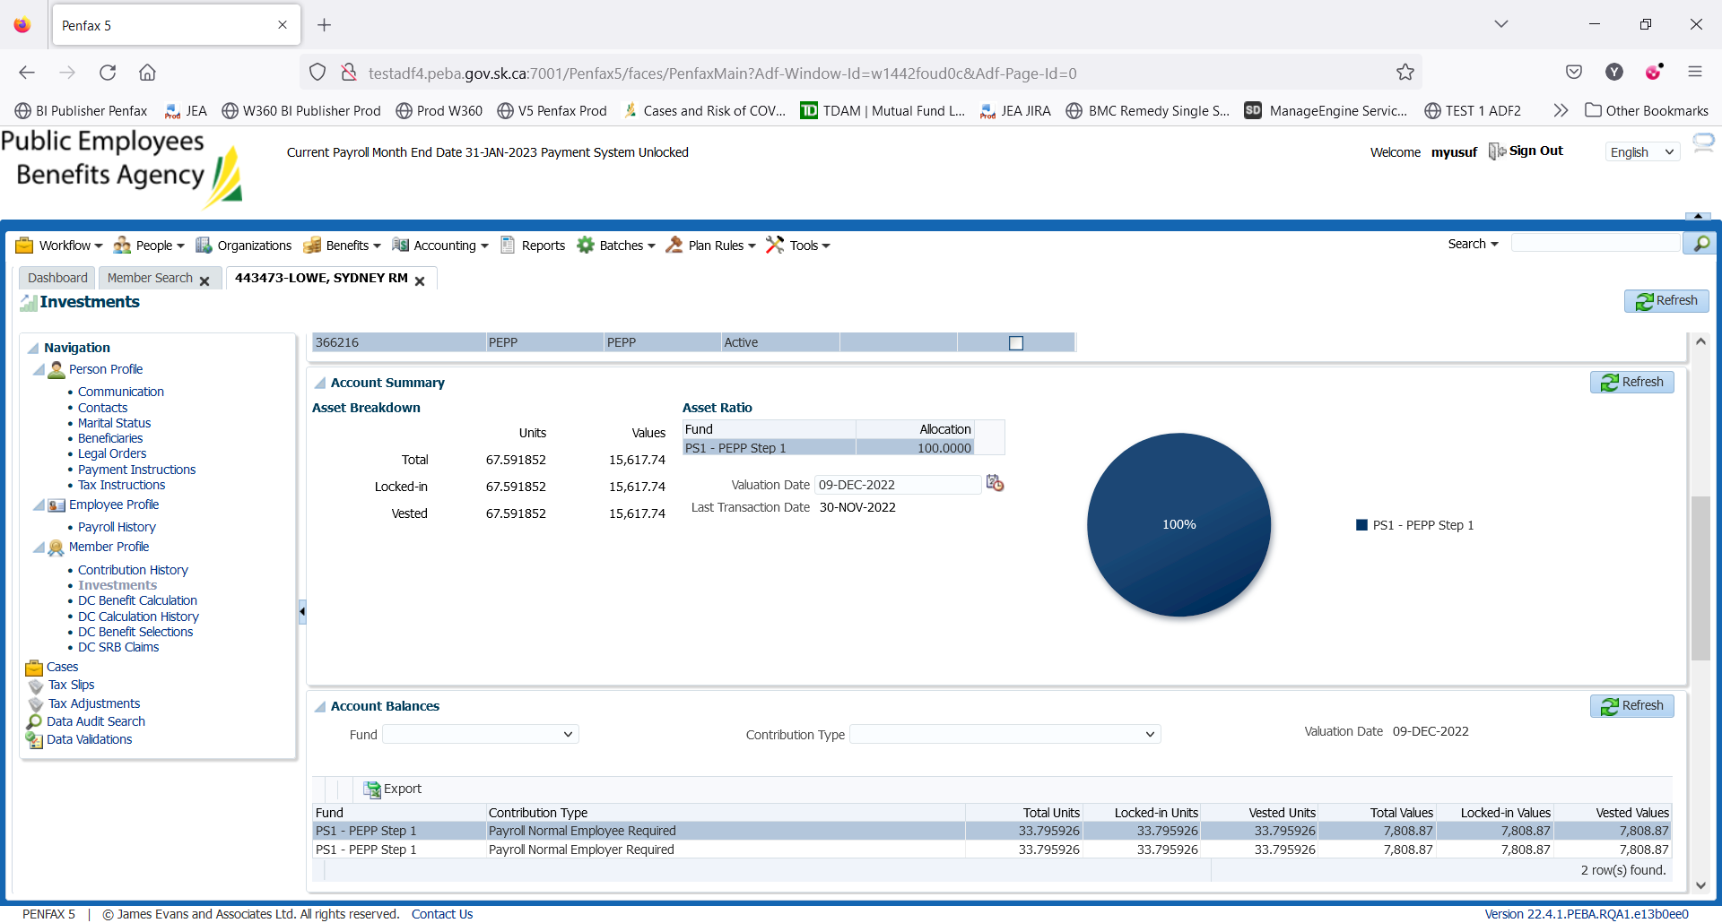

1. Member PLANet -> current allocation

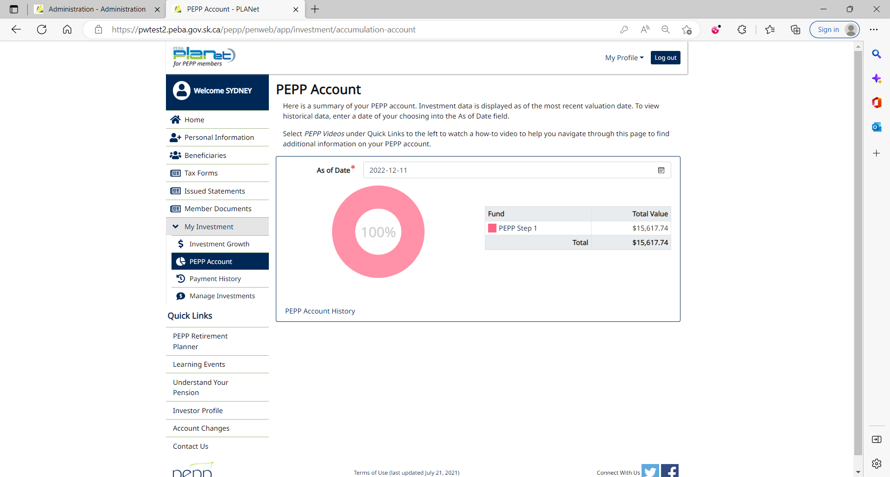

1. Go to Manage Investments to do interfund transfer.

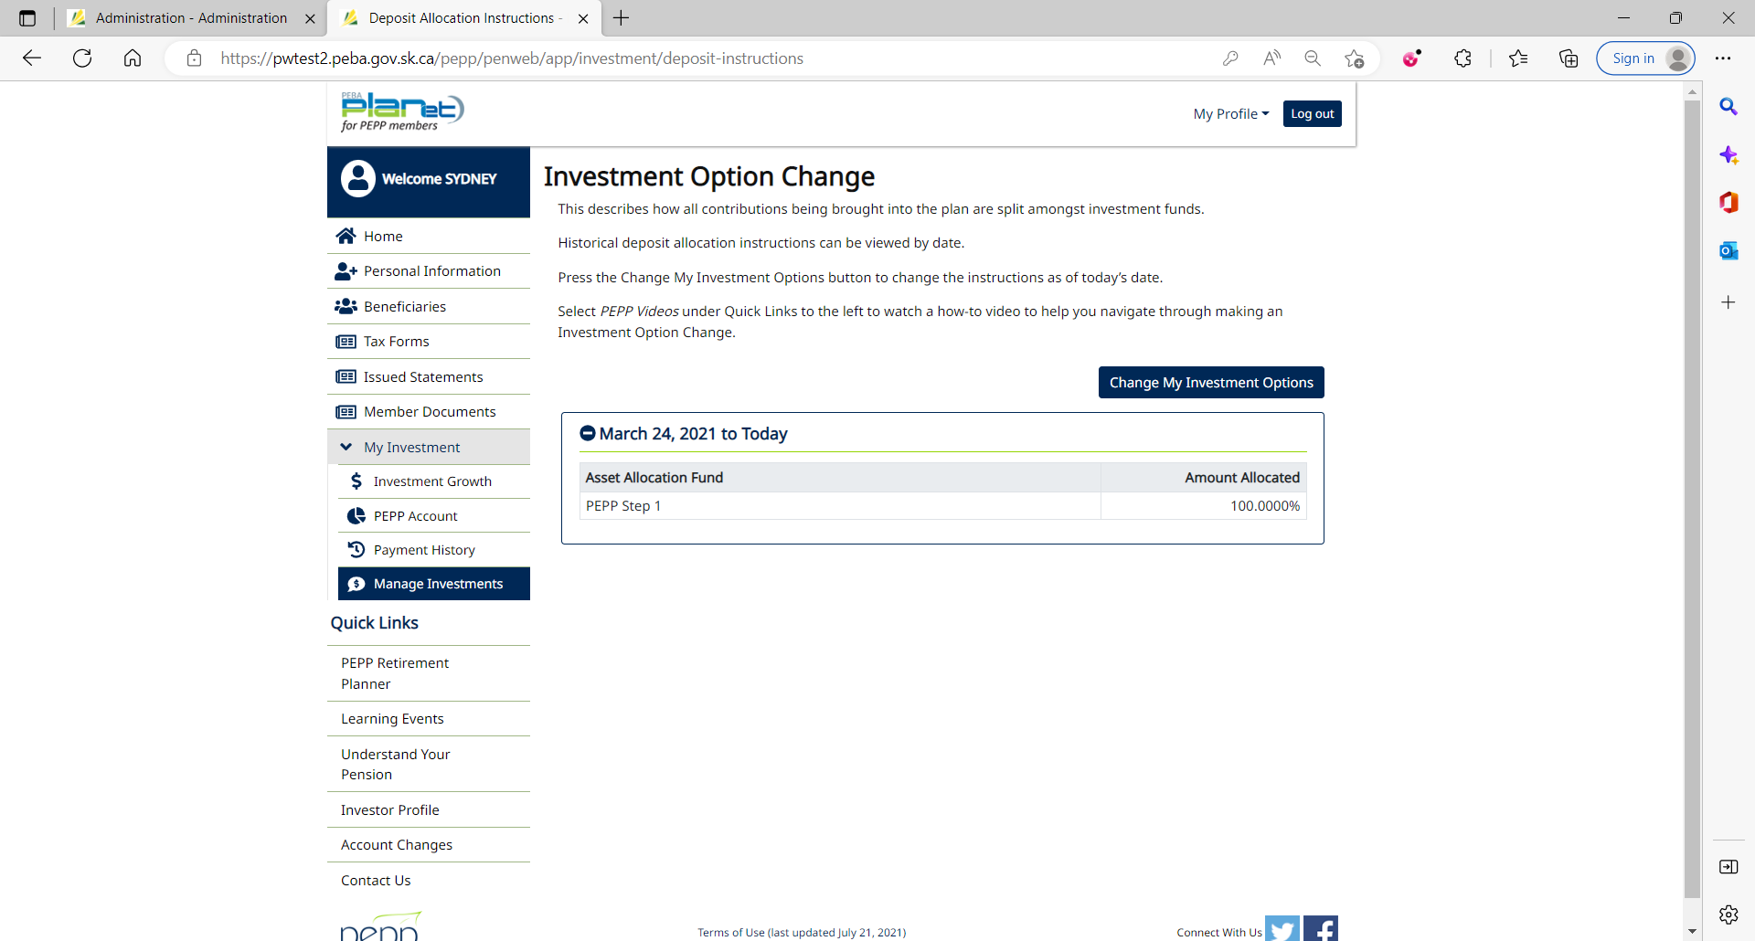

1. Click on Change My Investment Options.

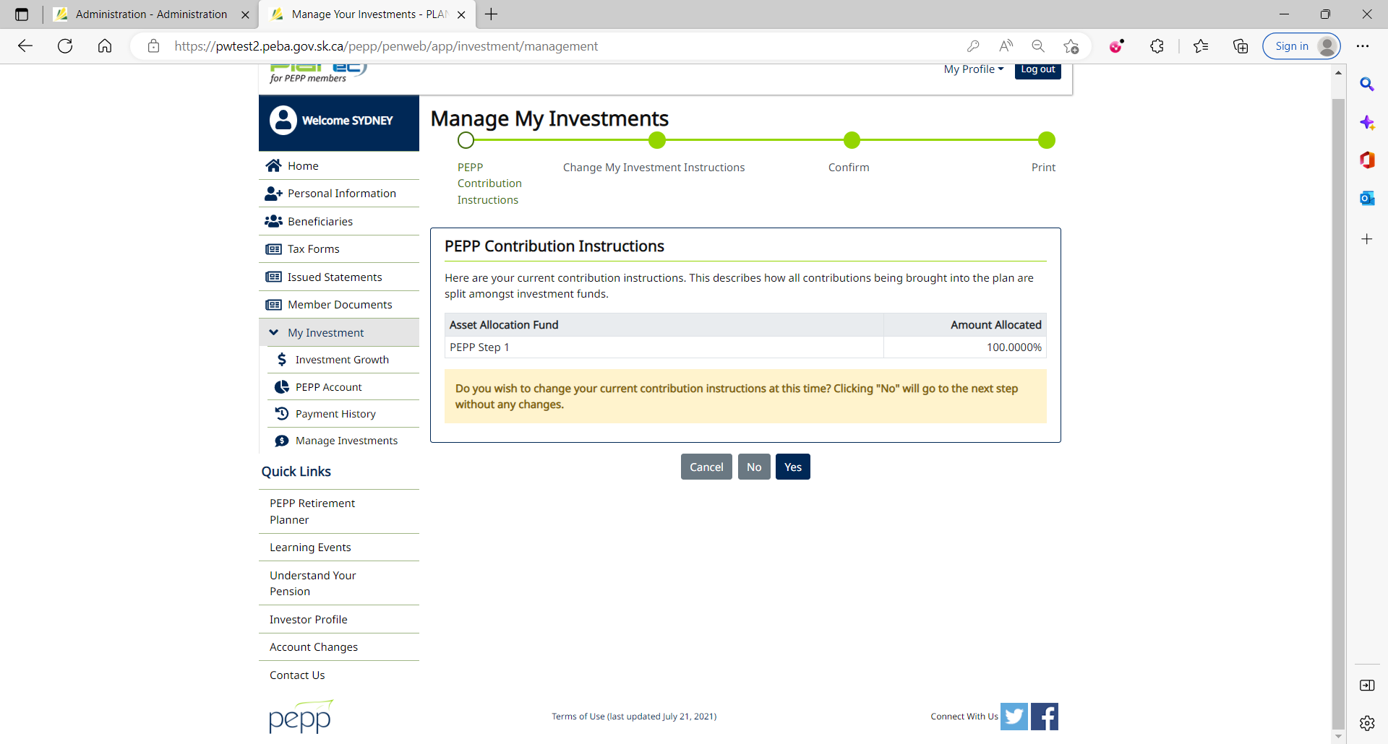

1. Click No.

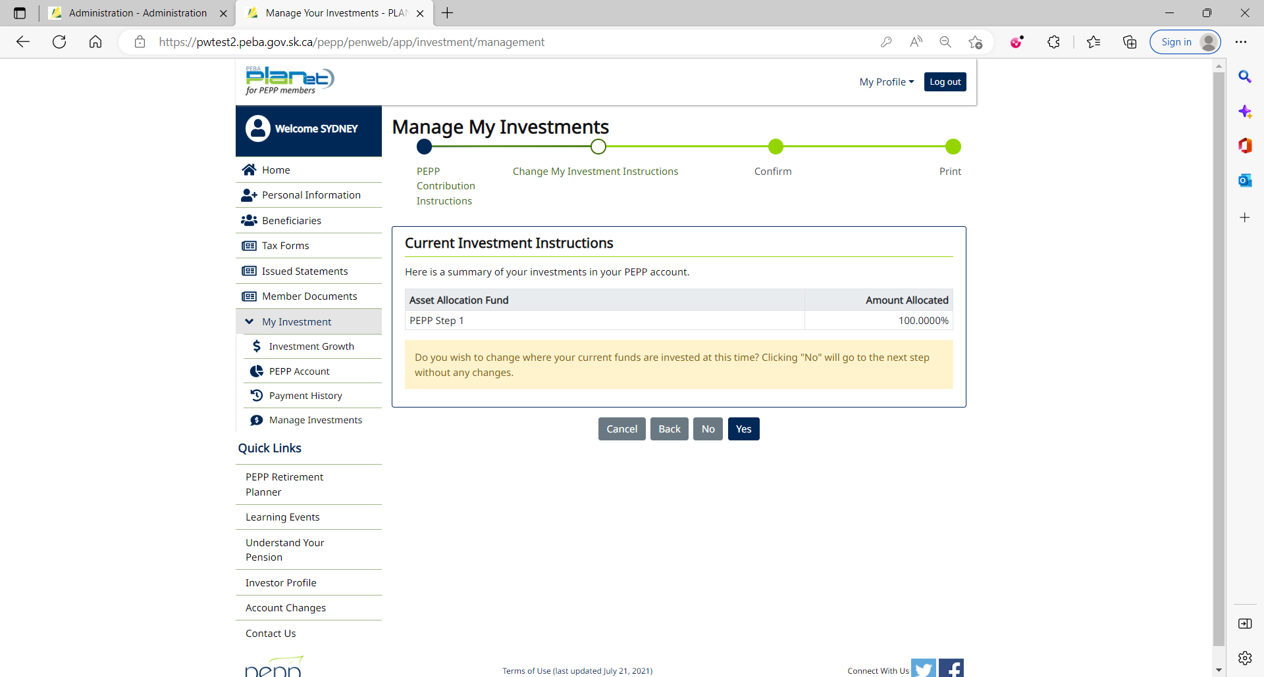

1. Click Yes.

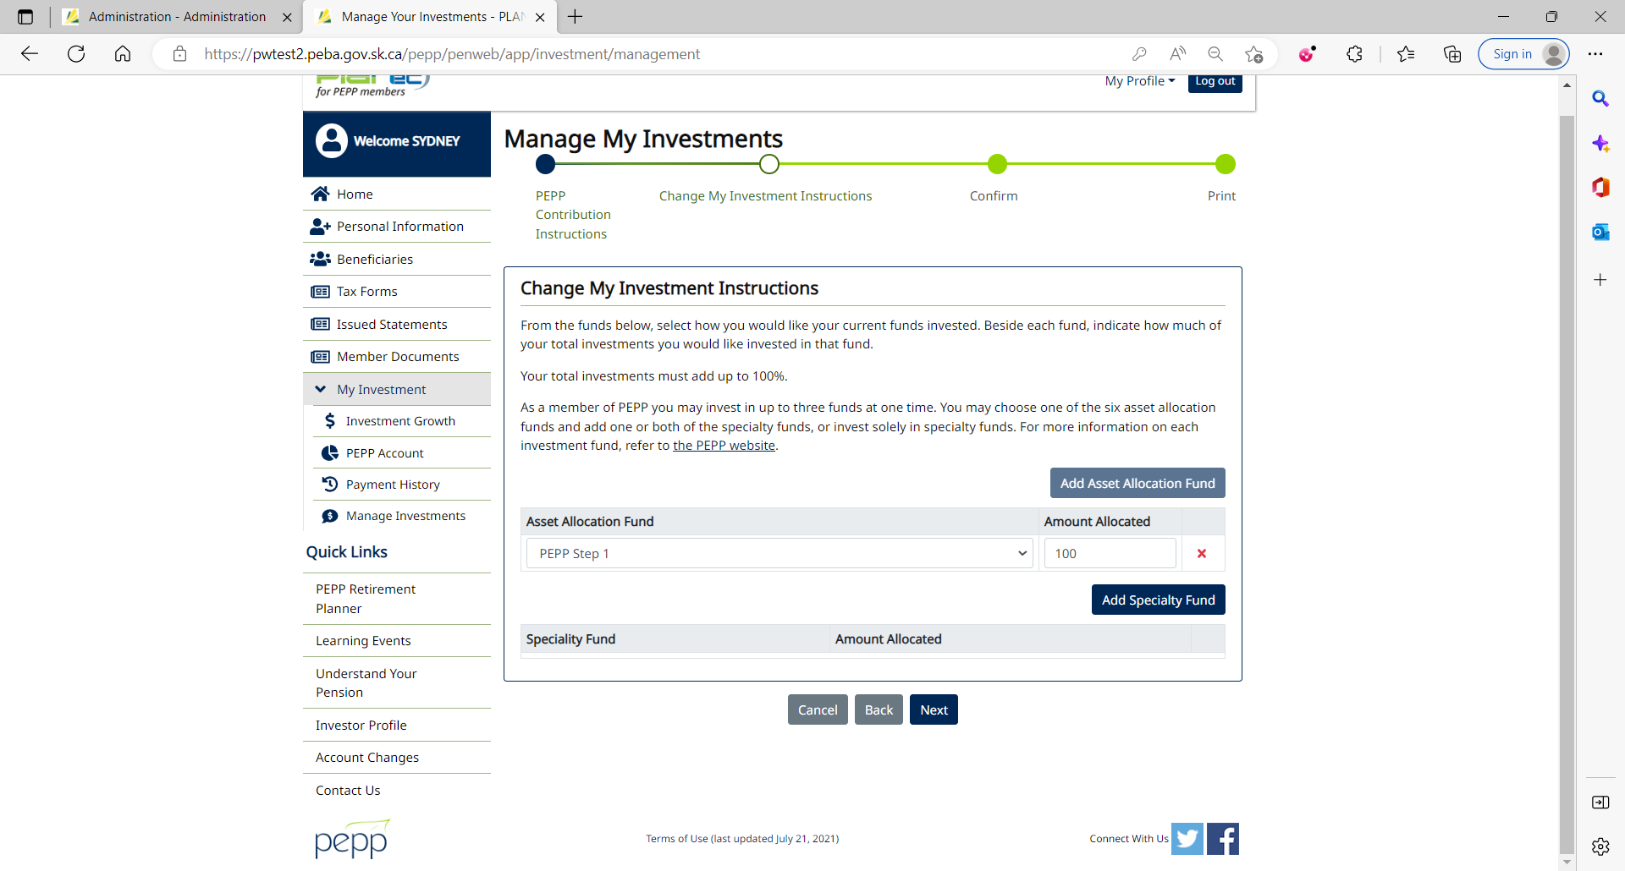

1. Current Investment Instructions



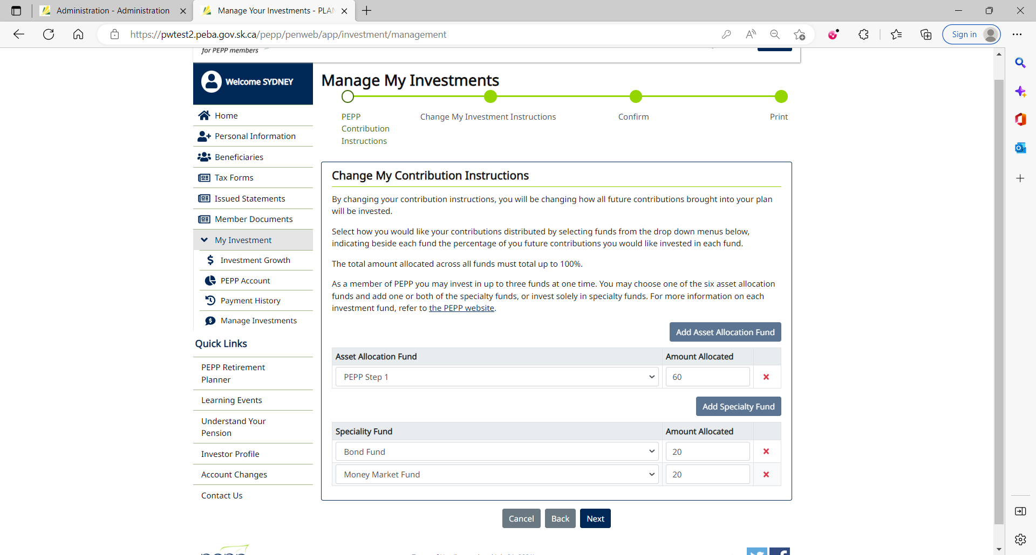

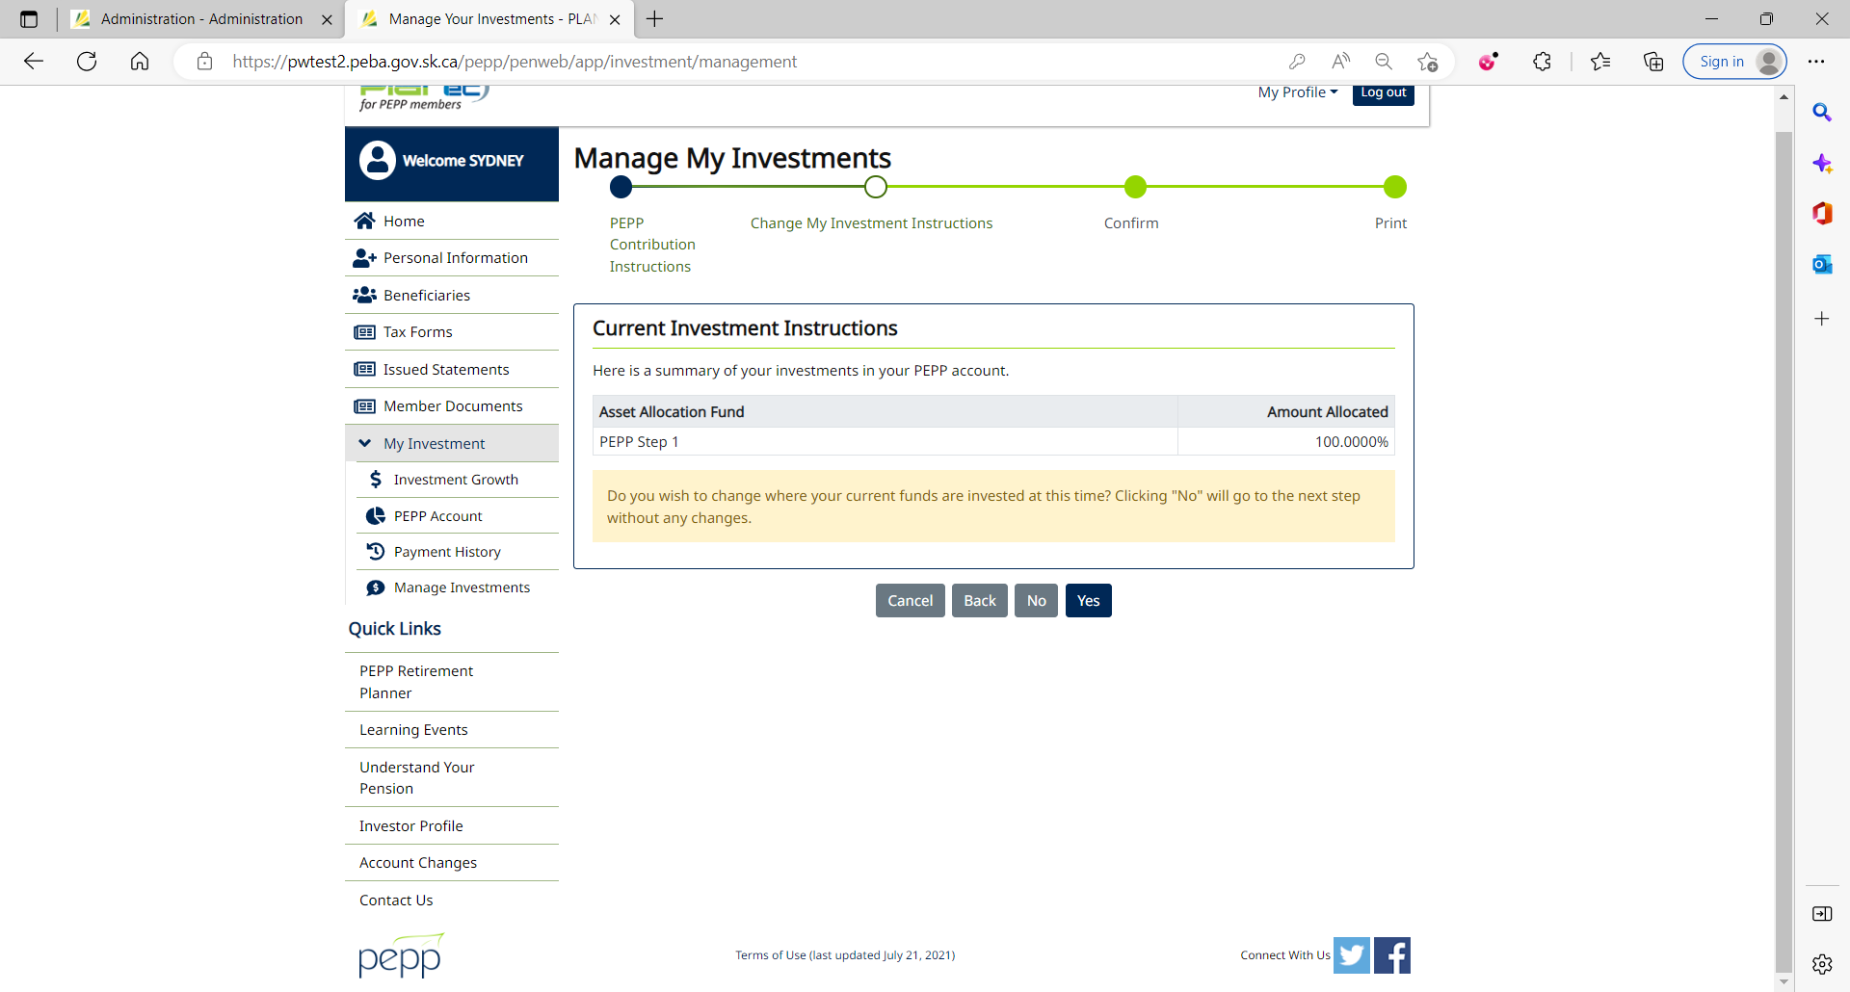

1. Select 3 asset allocation/specialty fund to which you want to transfer money and input the amount allocated. Click Next.

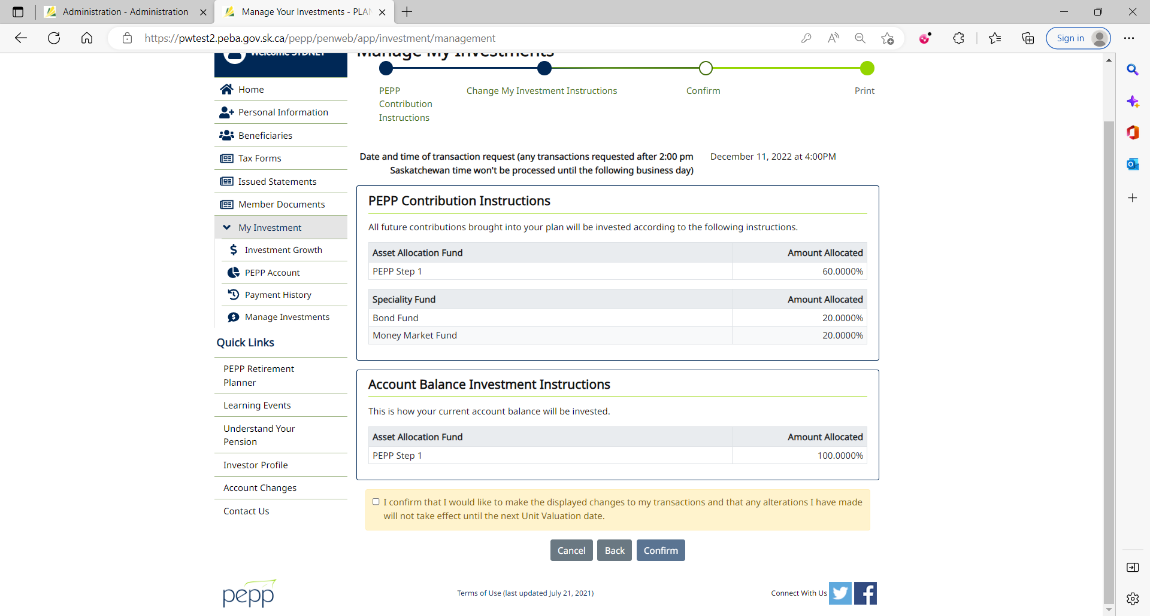

1. Tick the checkbox and click Confirm.

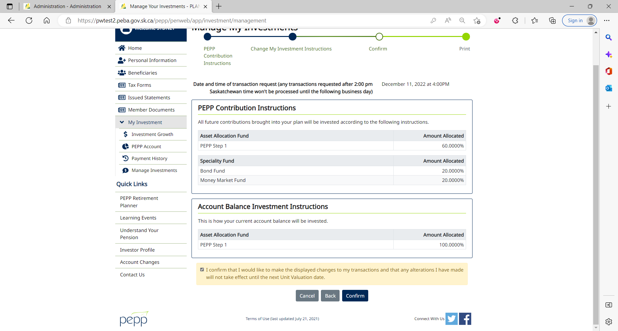

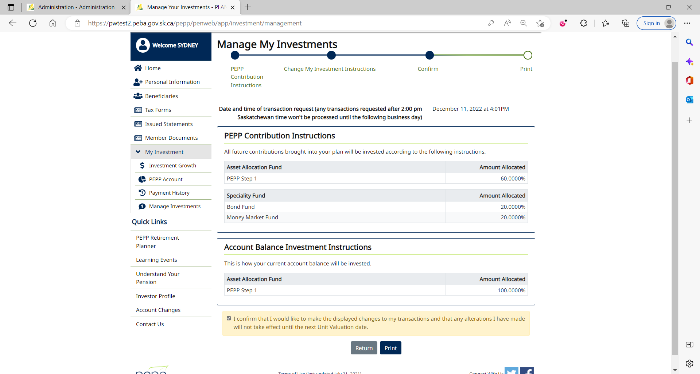

1. Interfund Transfer can immediately be seen under Account Instructions in Penfax with the Pending status.

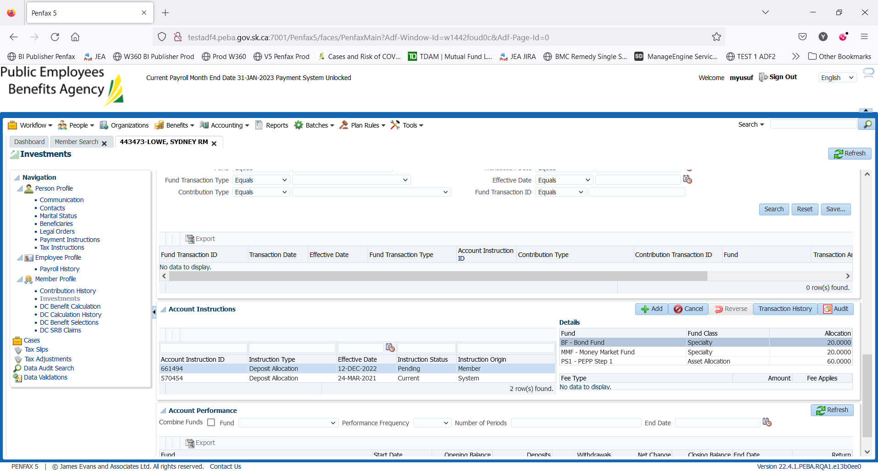

DAY 2

1. PIT batch was run overnight.
2. New DAI is now in current status but as Interfund Transfer was done in Member PLANet yesterday

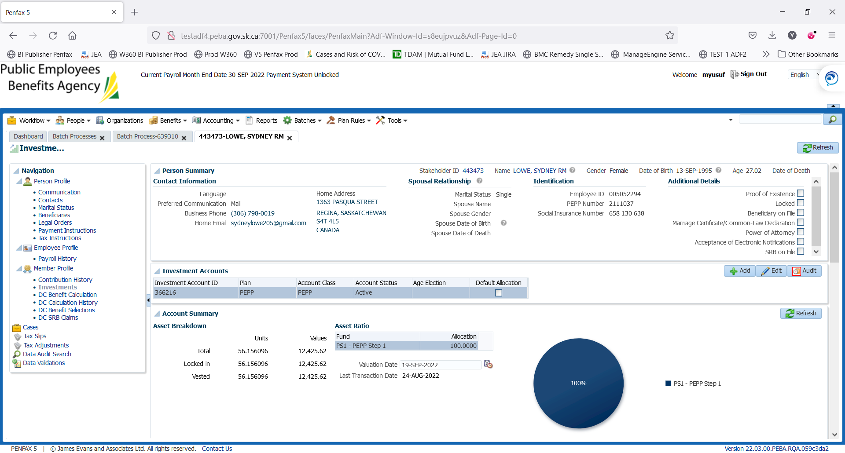

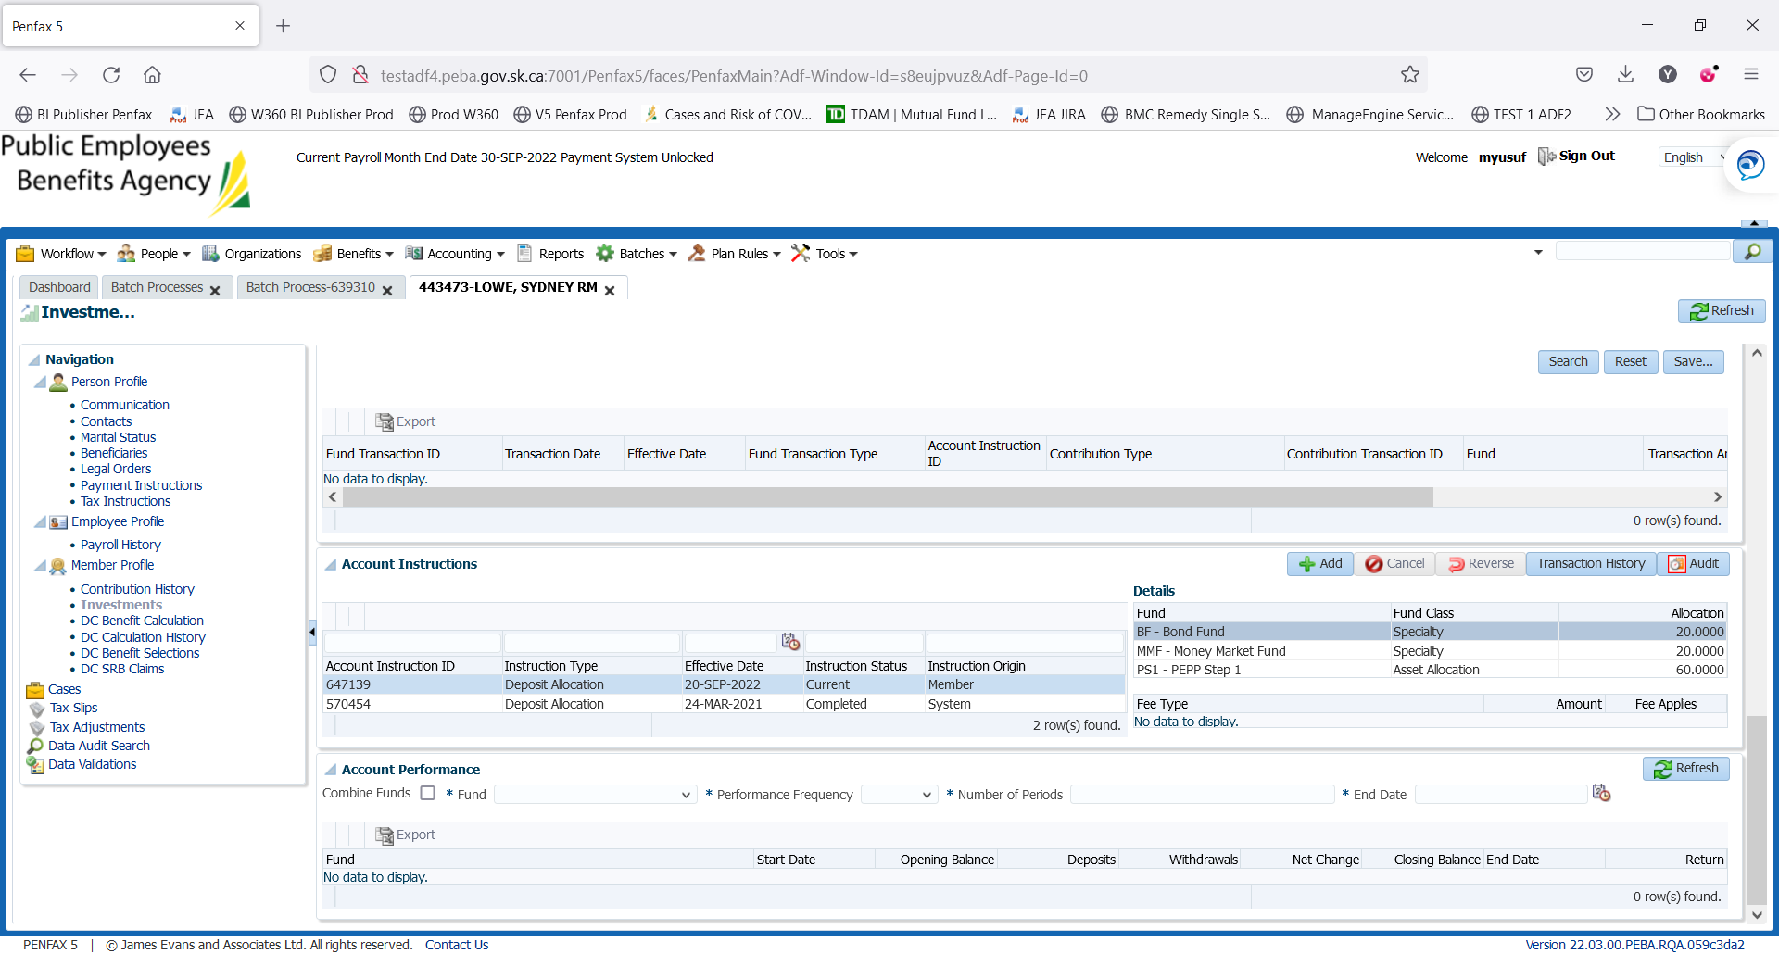

Transaction History of no Interfund Transfer

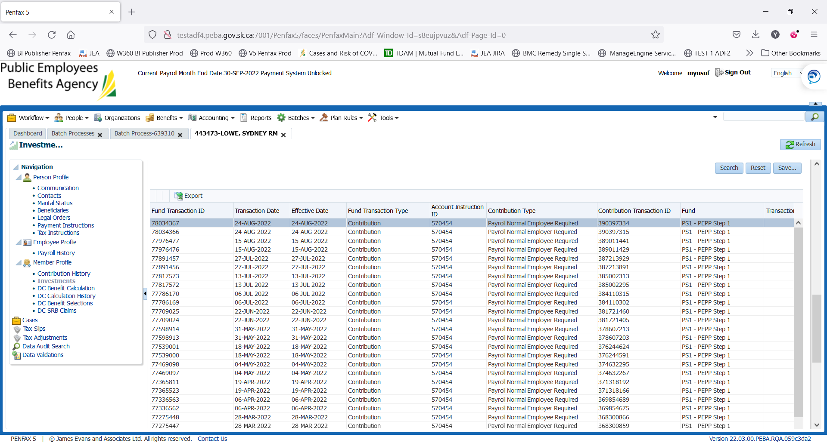

1. PEPP Interfund Transfer letter is available under Person Profile -> Communication -> Outbound Documents. – There should be no documents as it was deposit allocation not the interfund transfer

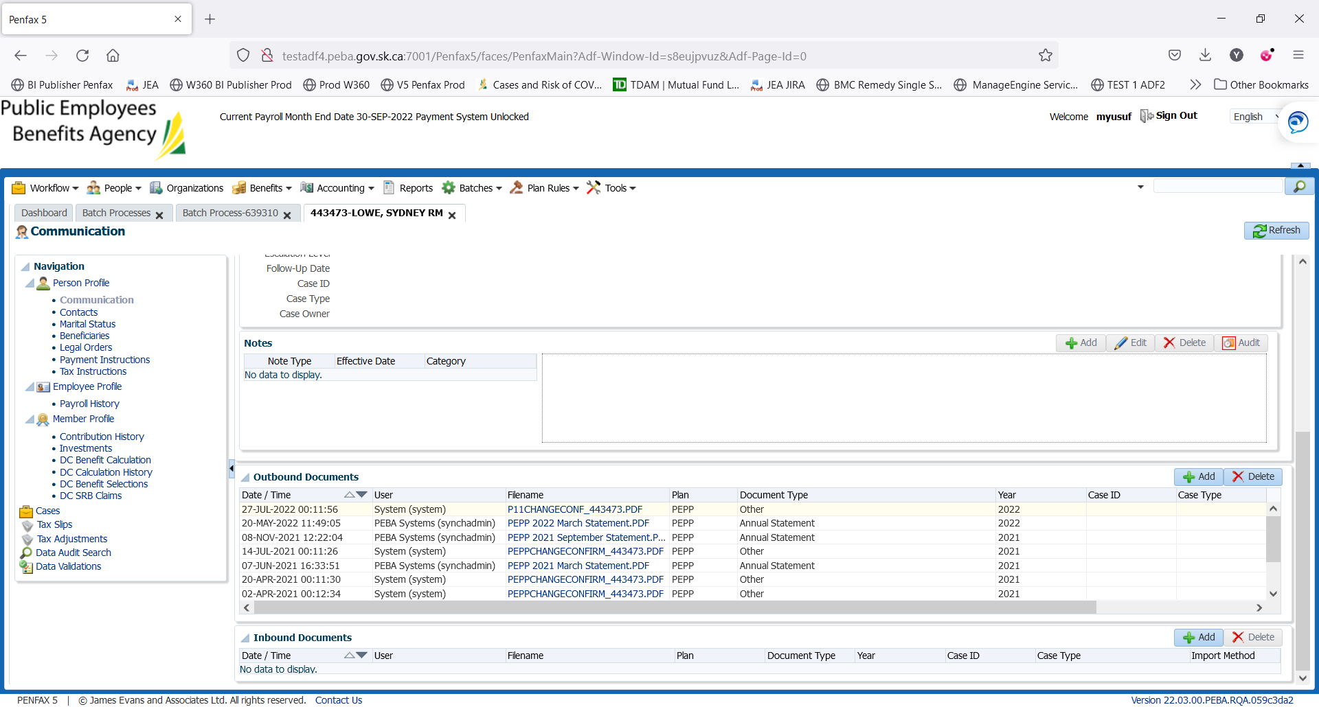

Member should not be present in Valuation reports and his PENWEB account should be same. As there was no transfer of money.

Transfer out

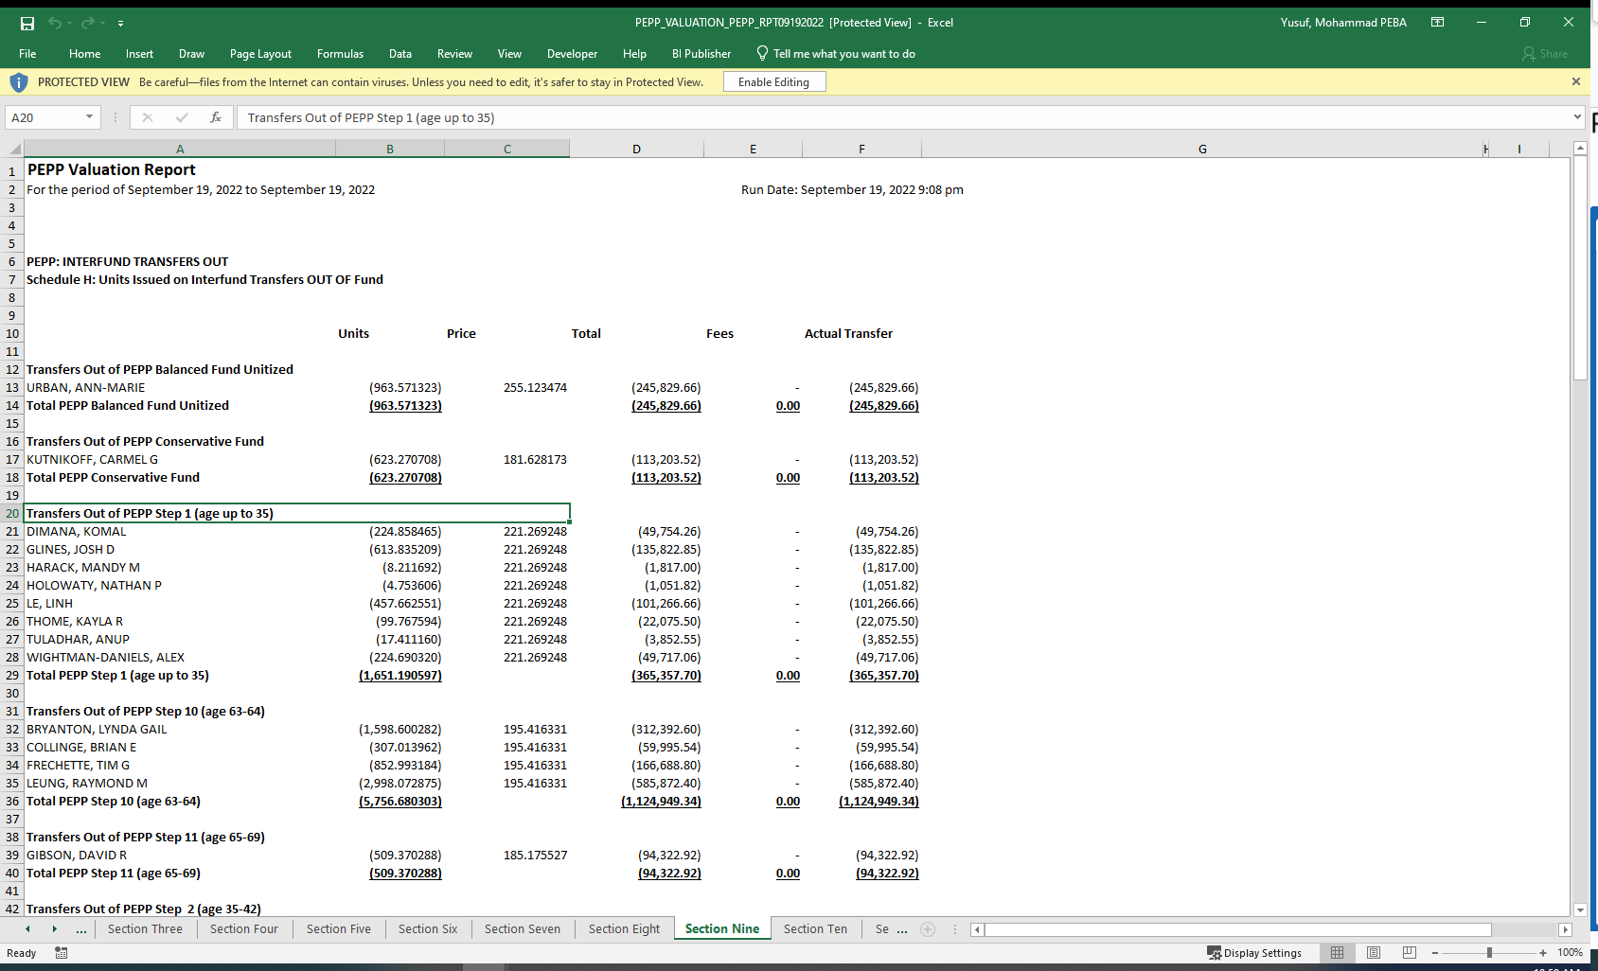

Transfer In

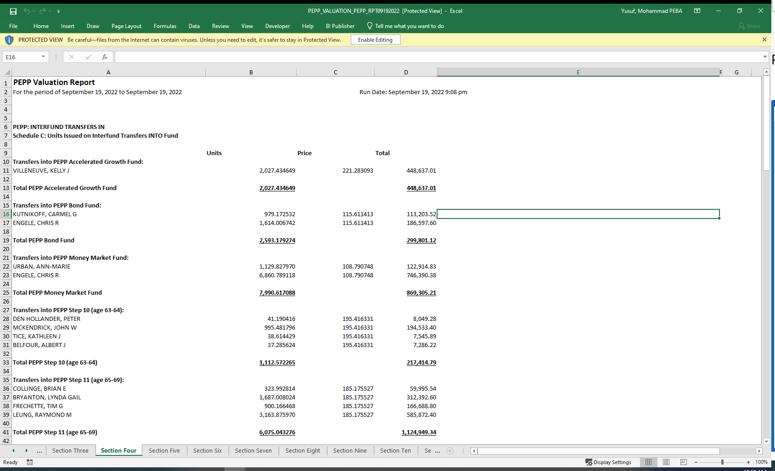Not in the reports

